Database analysis and design

Draft Tables

This is the initial mock-up of the tables I believe will be essential for the data-driven part of this task.

Users

* Customer
* Admin

Products

* Product details
* Drinks
* Food
* Stock
* Audit table

Order

* Order details

Draft Entities in each Initial table (pre normalisation)

This is the initial mock-up of some of the entities/attributes that I will use within the tables of the database. These fields will most likely be susceptible to change after further analysis of the database design.

Users

* UserID
* Username
* UserType
* Password
* FirstName
* LastName

Products

* ProductID
* ProductType
* Price
* Name
* Calories
* Image
* Details
* Stock/Quantity

Products Audit table

* ProductID
* Date Changed
* UserID
* UserType(Potentially for security reasons)
* Old values
* New values
* Added values
* Deleted values

Orders

* OrderID
* UserID
* ProductID
* OrderDate
* TotalPrice

Draft Normalisation of entities

This is the first attempt of normalising all of the attributes in the database.

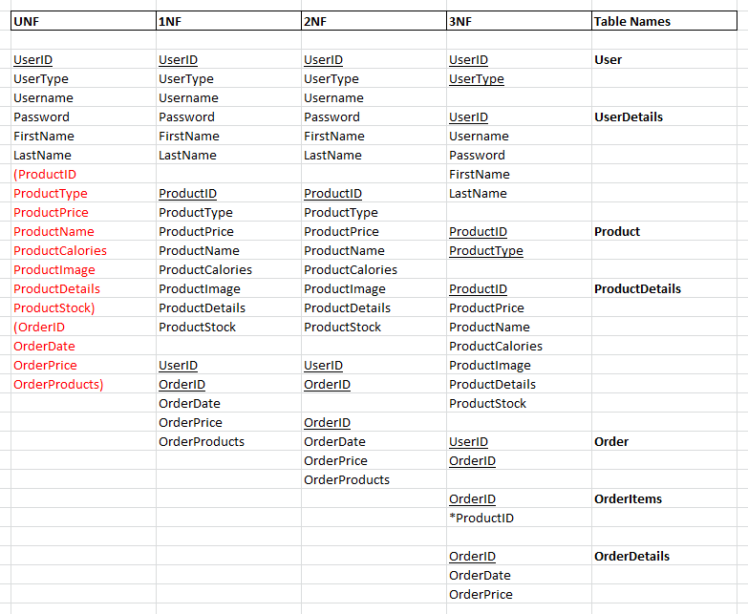

Analysis of database design:

I believe that this database design will provide a concrete and easy-to-use data structure to complete all of the application requirements in the task. However, whilst the design is robust, I also believe that it could create potential hindrances to the development process of the application in certain areas, such as with the user details. As I want to have a firm separation between a customer and admin within the data and application, it could be argued that it would be more beneficial to also separate the two user’s data into separate tables. I believe that this would be beneficial as it would make a firm distinction between these user’s, which would therefore help in the development process of this task as I will be able to specify which users will have the ability to access certain parts of the application (such as only allowing the admin’s to access the admin page of the application).